**CPR – *Half Life (Series)***

Gordon Freeman is the main character in this game and whom player is in *Half-Life (Series)*. The thing we realized is that we cannot see Gordon Freeman’s body (Only his holding weapon arms) and Gordon is speechless. Why we still love Gordon Freeman? Because Gordon Freeman was developed by NPCs (Non-Player-Characters) conversation and interactive environment in the game.

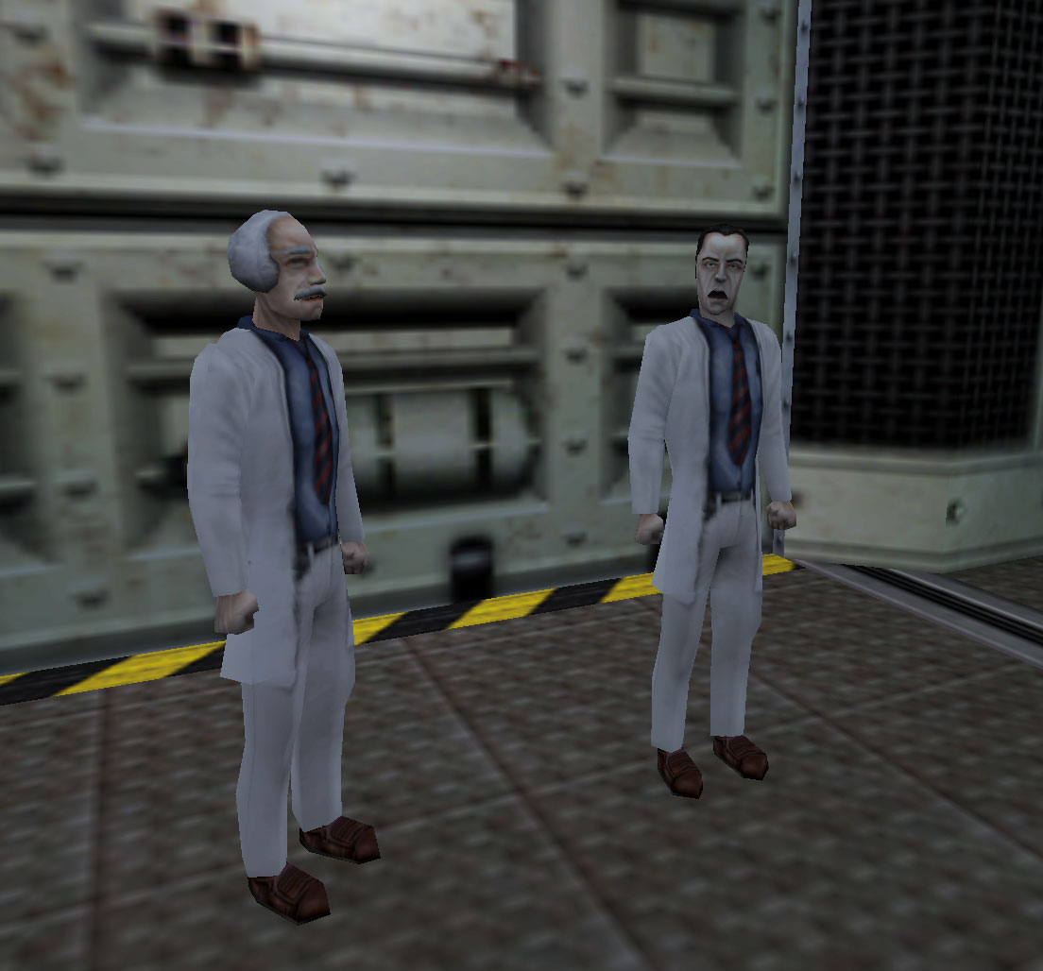

*Half-Life* set the story based on NPCs and puzzle solving. The conversation between NPCs is a critical and effective method to introduce Gordon Freeman. Figure 01 shows a conversation between two scientists. Their conversation maybe one of the most direct example to introduce Gordon Freeman to player.

*“Not now, if you’ll follow standard insertion procedures everything will be fine.”*

Figure 01

*“I don’t know how you can say that although I will admit that the possibility of a resonance cascade scenario is incredibly unlikely.”*

*“Gordon doesn’t need to hear all this, he’s a highly trained professional.”*

*(Half-Life, Chapter: “Anomalous Materials”, Valve, 1998)*

By the conversation, player learns more about who Gordon Freeman is and what others think about Gordon Freeman. In the game, Gordon has reaction from all the environment objects and NPCs. Such as pressing a button to call an elevator, pushing a cart to somewhere and even find a little trouble to the NPC. For example, in Figure 02, Gordon meets a security at the front desk at the entrance of Black Mesa. Behind the desk, Gordon can press a button to trigger the alarm. The alarm is noisy and the security will say, “My God! What are you doing? Come Gordon. You try to get me into trouble?” If Gordon reaches to other professors. They will say “Leave me alone.” Or “I can’t be bothered now.” and so on. Gordon Freeman, in the game, is a “real” person. He can do things, react with other people. We won’t need to learn Gordon by reading a long article about him. Just relax, listen to the conversation and keep the game going, you are not a floating camera. You are Gordon Freeman.

Figure 02

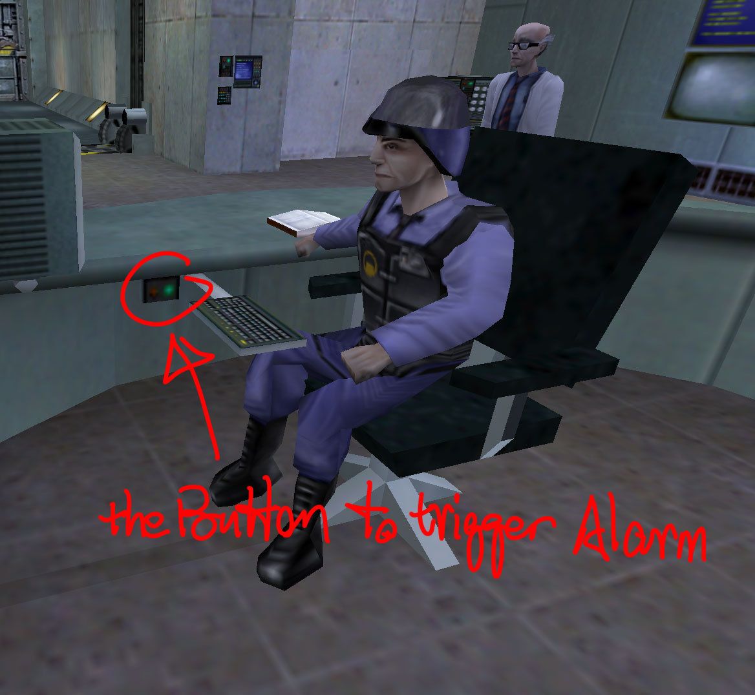

Besides the NPCs’ conversation, the interactive environment is also an important part to develop Gordon Freeman. Gordon is a live person in the game so that he can do things, engage in missions and fight against enemies. You’ll realize you are a “real” person in the game by solving puzzles in Gordon Freeman’s adventure. Gordon can climb a ladder, hold objects, swim and shoot guns. Based on the physical engine that used in *Half-Life 2*, Gordon can even do more things that make player immerse into the gameplay. For an instance, shows in Figure 03 to Figure 04, Gordon came into a space that has seesaw structured wood board and concrete pipe, and some bricks on the ground. The wall is too high to jump on. What these stuff means? Try to stack bricks at one end of the wood board and rise another end up? Yes! Now you can go through the high wall. That’s how Gordon solves a puzzle. Puzzles in *Half-Life* not only builds the game story but also develops Gordon Freeman. Player immerses into Gordon’s adventure, interact with the environment around him, and also get more understand who Gordon Freeman is.

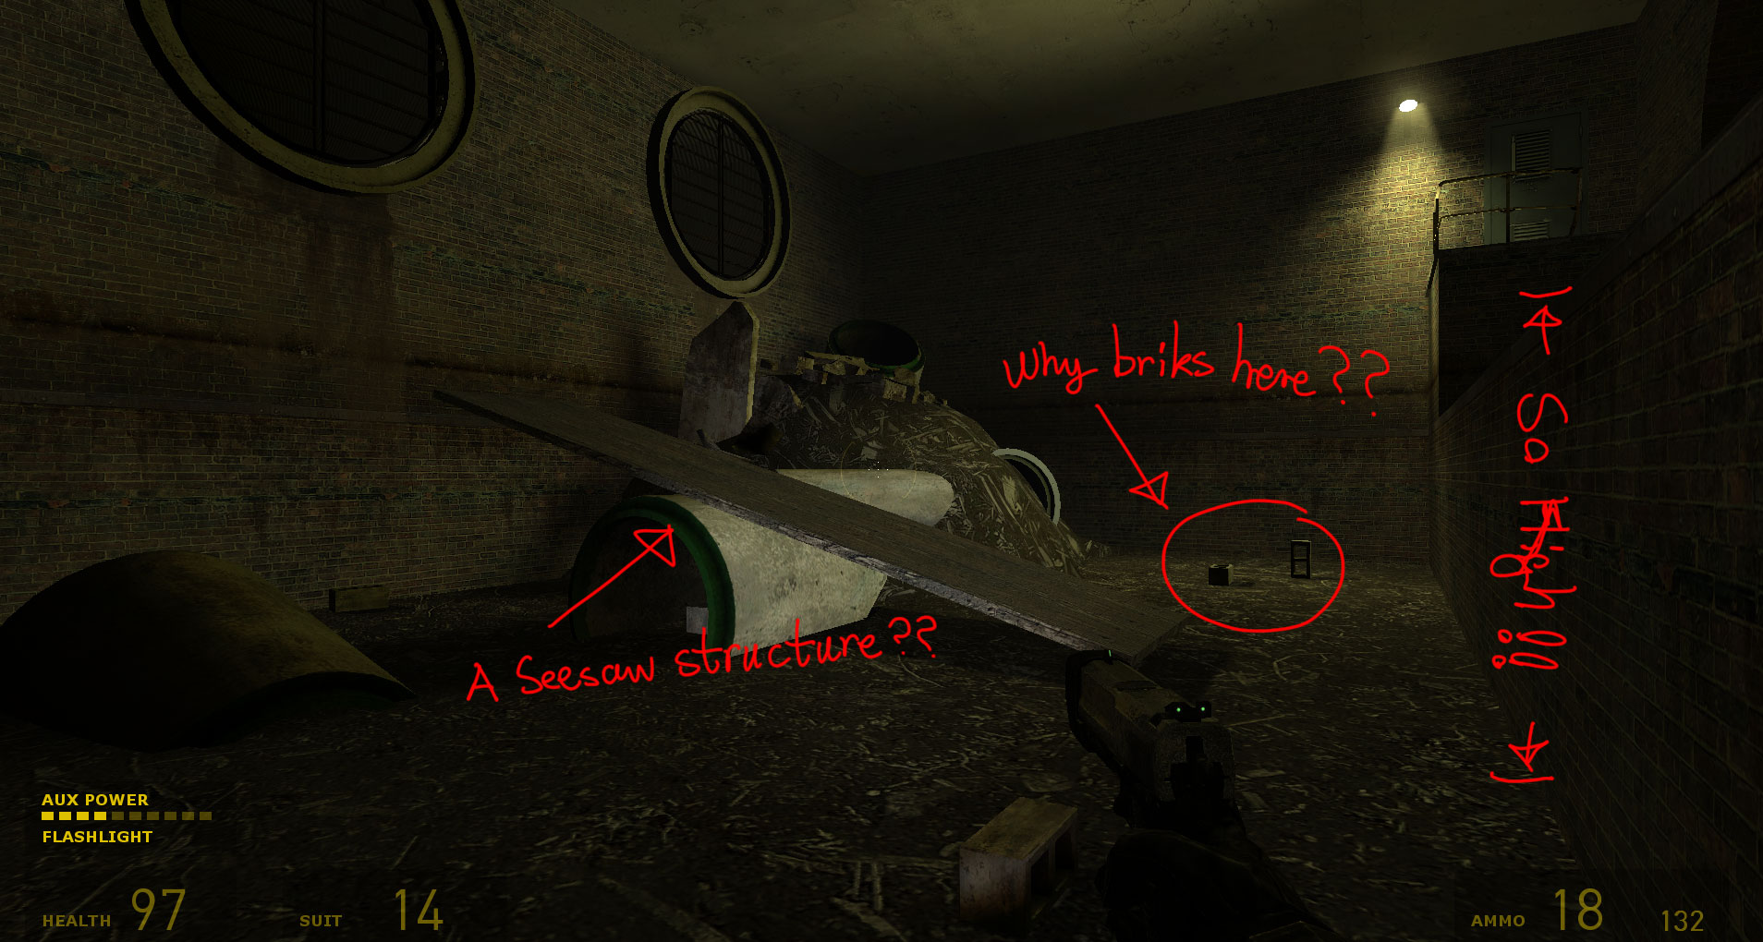

Figure 03

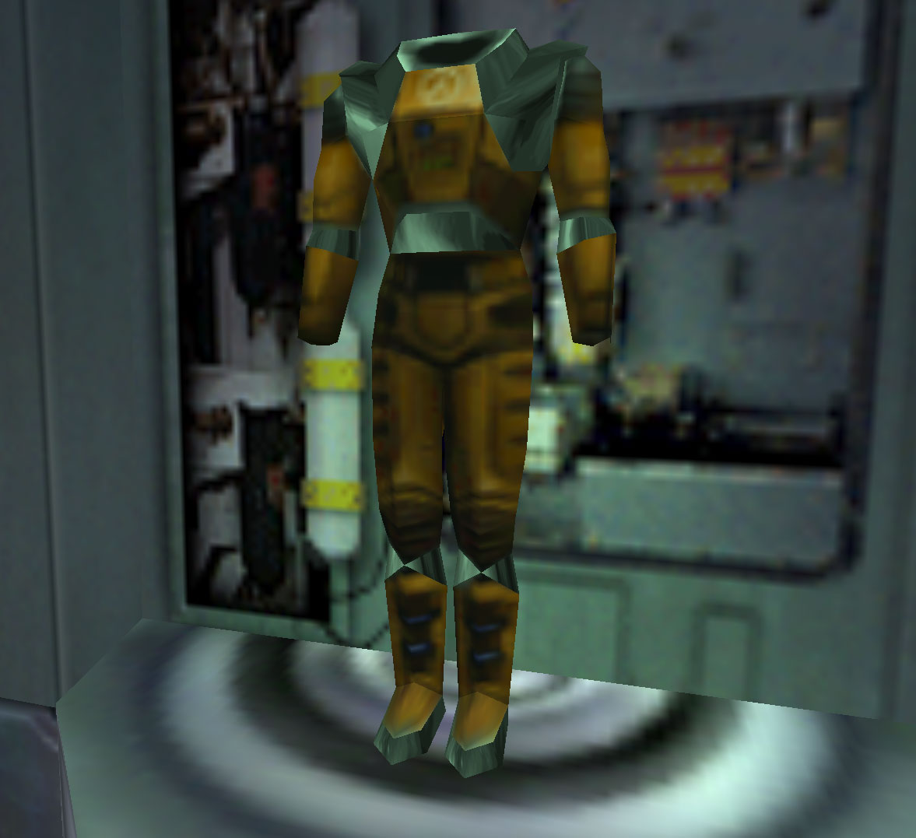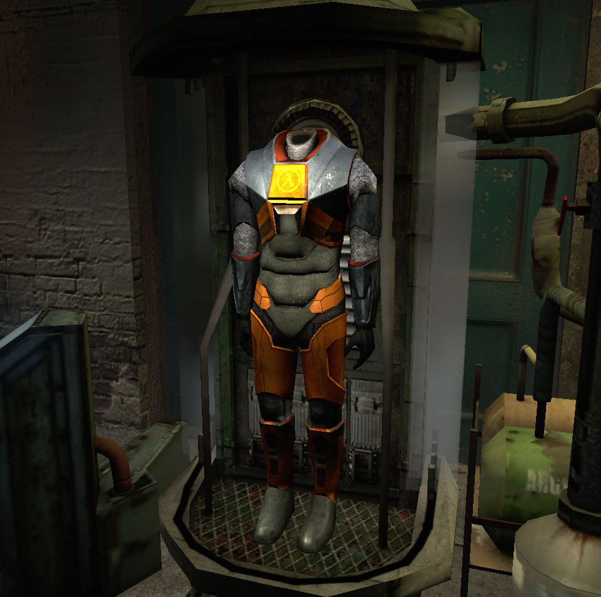

*Half-Life 2* pushes *Half-Life series* into a significantly high level. One of the improvements that player can notice at the first sight is polished visual design. Comparing Figure 05 and Figure 06, we can easily realize the huge visual improvement for Gordon’s HEV suit between *Half-Life* and *Half-Life 2*. By the legible details on HEV, we can imagine more clearly about how Gordon Freeman looks like in the game.

Figure 04 Figure 05

In summary based on what we’ve discussed above, I believe that Gordon Freeman is a successfully developed game character in game history. We love Gordon Freeman even though we cannot see his body and hear his language. But NPCs conversation and interactive environment in the game story helped we established a “real” Gordon Freeman in the game. I love *Half-Life series* and Gordon Freeman very much, so that’s why my name is Gordon as well.